**The Eatwell Guide**

* When choosing food and drinks, current healthy eating guidelines should be followed.

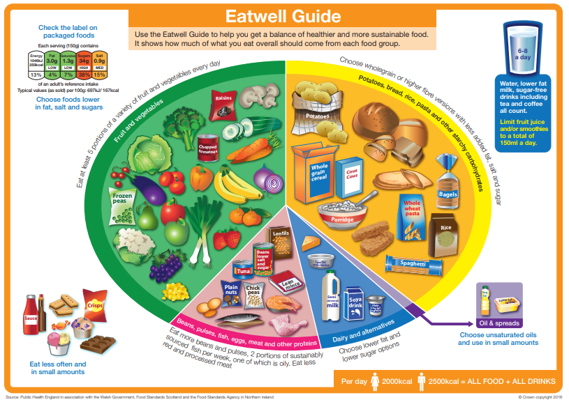

**Composite/combination food**

Much of the food people eat is in the form of dishes or meals with more than one kind of food component in them. For example, pizzas, casseroles, spaghetti bolognese and sandwiches are all made with ingredients from more than one food group. These are often called ‘combination’ or ‘composite’ foods.

**8 tips for healthier eating**

These eight practical tips cover the basics of healthy eating, and can help you make healthier choices.

1. Base your meals on starchy carbohydrates.
2. Eat lots of fruit and veg.
3. Eat more fish – including a portion of oily fish.
4. Cut down on saturated fat and sugar.
5. Eat less salt (max. 6g a day for adults).
6. Get active and be a healthy weight.
7. Don’t get thirsty.
8. Don’t skip breakfast.

**The Eatwell Guide**

* Comprises 5 main food groups.
* Is suitable for most people over 2 years of age.
* Shows the proportions in which different groups of foods are needed in order to have a well-balanced and healthy diet.
* Shows proportions representative of food eaten over a day or more.

**Key terms**

**The Eatwell Guide**: A healthy eating model showing the types and proportions of foods needed in the diet.

**Hydration:** The process of replacing water in the body.

**Dietary fibre**: A type of carbohydrate found in plant foods.

**Composite/combination food**: Food made with ingredients from more than one food group.

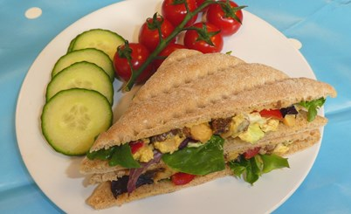

**Fruit and vegetables**

* This group should make up just over a third of the food eaten each day.
* Aim to eat at least five portions of a variety each day.
* Choose from fresh, frozen, canned, dried or juiced.
* A portion is around 80g (3 heaped tbs).
* 30g of dried fruit or 150ml glass of fruit juice or smoothie count as a max of 1 portion each day.

**Beans, pulses, fish, eggs, meat and other protein**

* Sources of protein, vitamins and minerals.
* Recommendations include to aim for at least two portions of fish a week, one oily, and;

people who eat more than 90g/day of red or processed meat, should cut down to no more than 70g/day.

**Hydration**

* Aim to drink 6-8 glasses of fluid every day.
* Water, lower fat milk and sugar-free drinks including tea and coffee all count.
* Fruit juice and smoothies also count but should be limited to no more than a combined total of 150ml per day.

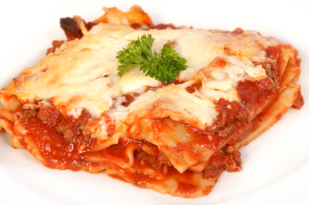

**Fibre**

* Dietary fibre is a type of carbohydrate found in plant foods.
* Food examples include wholegrain cereals and cereal products; oats; beans; lentils; fruit; vegetables; nuts; and, seeds.
* Dietary fibre helps to: reduce the risk of heart disease, diabetes and some cancers; help weight control; bulk up stools; prevent constipation; improve gut health.
* The recommended average intake for dietary fibre is 30g per day for adults.

To find out more, go to: <https://bit.ly/2QzUMfe>

**Task**

Plan a menu for a day that applies the principles of The Eatwell Guide and the 8 tips for healthier eating. Make one of the dishes, complete a sensory evaluation and calculate the energy and nutrients provided using nutritional analysis.

**Foods high fat, salt and sugar**

* Includes products such as chocolate, cakes, biscuits, full-sugar soft drinks, butter and ice cream.
* Are high in fat, sugar and energy and are not needed in the diet.
* If included, should be had infrequently and in small amounts.

**Oil and spreads**

* Unsaturated fats are healthier fats that are usually from plant sources and in liquid form as oil, e.g. olive oil.
* Generally, people are eating too much saturated fat and need to reduce consumption.

**Dairy and alternatives**

* Good sources of protein and vitamins.
* An important source of calcium, which helps to keep bones strong.
* Should go for lower fat and lower sugar products where possible.

**Potatoes, bread, rice, pasta or other starchy carbohydrates**

* Base meals around starchy carbohydrate food.
* This group should make up just over a third of the diet.
* Choose higher-fibre, wholegrain varieties.

**Meals and snacks can be sorted into The Eatwell Guide food groups.**

**Composite/combination food - Lasagne**

Pasta (lasagne sheets): **Potatoes, bread, rice, pasta or other starchy carbohydrates**

Onions, garlic and chopped tomatoes: **Fruit and vegetables**

Lean minced meat (or meat substitute): **Beans, pulses, fish, eggs, meat and other protein**

Cheese sauce made with milk and cheese**: Dairy and alternatives**

Olive/vegetable oil used to cook onions and mince**: Oil and spreads**